**Corvedale & District Autumn Show**

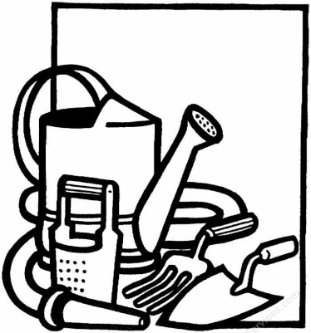

**The complete Schedule for this year’s show is now available to download at:**

[**http://www.diddleburyparish.co.uk/corvedale-and-district-autumn-show**](http://www.diddleburyparish.co.uk/corvedale-and-district-autumn-show)

**You will find us under the ‘Community’ tab in the ‘banner’ at the top of the Parish Council’s ‘home’ page.**

**It is hoped that, Covid 19 infection rates permitting, it will be possible for the Corvedale & District Autumn Show to return on:**

**Saturday 3rd September 2022**