Diddlebury Parish
Flood
Resilience Plan

Diddlebury Parish Flood Action Group

Version Five

Flood Resilience Plan

Flood Action Group lead: Clive Martyn

Current Version: Version 5
Date Completed: November 2023

Review date: September 2024

Data Protection Disclaimer

This community Flood Plan is owned by Diddlebury Parish Flood Action Group and is marked as RESTRICTED as it contains sensitive and personal information. By accepting receipt of this plan and the information contained within it, the recipient agrees that this document will not be:
- Passed on to any third parties;
- Placed on any website;
- Copied into any other documentation.
Please sign below to confirm that these conditions are accepted.

Flood Action Group Lead: Date: November 2023

Summary of Flood Risk

History of Flooding

History of flooding

Due to the generally steep nature and small size of the catchments, flooding happens quickly and recedes quickly. Generally, the water has receded after an hour or two.
In Bouldon, Bouldon Farm is worst hit with the yard and the house both being flooded to around 1m in the past. The car park at the Tally Ho public house has flooded. The problem is worsened by blocked road drains.
At Peaton Strand, the road floods and some properties have had flood waters inside them. Flooding occurs on the road between Peaton and Peaton Strand. Peaton Cottage has flooded to a depth of 300mm.
In Peaton itself, the Pye Brook will overtop its banks and revert to its original course and that of an old mill race coming through the farm yard , across the road and into the outbuildings of Brook Cottage. This has been aggravated by blocked road drains.
At Sutton, the road floods near Patch House – again aggravated blocked a blocked culvert.
In Lower Corfton Karray Cottage has flooded on several occasions in tth epast. Warwick Cottage on the B4368 flooded in February 2020. The current owners had to place sandbags to prevent renewed flooding in December 2020.
In Middlehope there was minor flooding to the garage beloinging to Lower Middlehope Barn in February 2020 and the road in the village suffers from serious flooding due blocked drains in the past.
In Diddlebury Glebe Cottage by the bend at the bottom of Mill Lane has flooded on three occasions. In 2009, the Diddle Brook reverted to its old course across the front garden of Glebe Farm and entered Glebe Cottage from the rear. On the second occasion, water from Mill Lane entered from the front of the house. The third instance was a reoccurance of flooding due to the brook crossing the garden of Glebe Farm. The owners, with assistance from the Council, have now installed flood gates and some tanking. Since that time (which coincided with the installation of 50 leaky dams upstream) no flood water has penetrated the defences. Mill Lane itself was impassable to traffic (including traffic to and from the Corvedale Primary School) for over an hour. In February 2020 the grounds of Delbury Hall were inundated. The nearby Malthouse was flooded to a depth of half a metre.
Roseford, the house immediately above the bridge on the B4368 in Diddlebury has suffered from flooding 5 times since 2000. The owner has installed some flood prevention measures but these were overtopped in February 2020. A ford across the Diddle Brook in Bache Mill is sometimes impassable. A further two properties in Bache Mill have experienced minor flooding, and damage to their river defences.
The February 2020 storm caused flooding in the Covredale Cof E School and a farm building belonging to Topher Morgan.
The bridge taking the B4368 over the Diddle Brook was flooded in February 2020 and October 2023, due to blocked drains.
The small sewage pumping station in the green lane between Glebe Farm and Willowbrook on Mill Lane has flooded when the Diddle Brook tops its banks and water floods down this green lane to Mill Lane. The PS has recently been adopted by Severn Trent.
Sand bags for emergencies are availbale for the Highways depot in Craven Arms.
In recent times, 2007, 2009, 2012, 2020 and 2023, were bad years for flooding.
There is a perception in Diddlebury that since the erection of leaky dams in the Diddle Brook upstream of Diddlebury, both the frequency and severity of flooding have decreased.

Sources of Flooding

1 Watercourses
Within the Parish there are two major tributaries of the River Corve which itself almost bisects the Parish. These are the Diddle Brook rising on Wenlock Edge and running through Diddlebury village to the Corve, and the Pye Brook (with it’s tributaries), rising on Brown Clee Hill and running through Bouldon, Peaton Strand, Peaton and Sutton before joining the Corve in the neighbouring Parish of Culmington.
As the Corve runs mainly through agricultural land and only crosses one road within the Parish (beneath a newly built bridge), it is not a major flood risk to property.
The Diddle Brook has caused flooding in Diddlebury Village and Middlehope.
The Pye Brook has caused flooding in Bouldon, Peaton Strand and Peaton.
A smaller watercourse, Corfton Bache which also rises on Wenlock Edge, has caused some flooding in Corfton.

2 Field run off
This causes flooding of roads – mainly in the Peaton Strand and Sutton areas.

3 Road run off
Surface water running down the lane from Pinstones Farm to the B4368 at the entrance to Diddlebury village has in the past aggravated flooding further down Mill Lane. Run off from this road and the lane running beside Corfton Bache has done the same in Corfton.

Sources of Flooding
There

Contact List

IF LIFE IS AT RISK DIAL 999

Service / Name | Contact Number  (Office Hours) | Contact Number  (Out of Office Hours) | Additional Information
Floodline | 0845 988 1188 | 0845 988 1188 | fwd.environment-agency.gov.uk
County Flood Management | 0345 678 9006 |  | flood@shropshire.gov.uk
Diddlebury Parish Flood Action Group | 07803184778 |  | Happy4clive@gmail.com
Police (non emergency) | 07773054602 | 101 | contactus@westmercia.police.uk
Fire and Rescue | 01743 260200 | 01743260200
Emergency Planning Shropshire Council | 01743 260290 | 01743 260290 | Ask for the Emergency Planning Duty Officer for Shropshire Council to be paged on X002 – giving a brief message, name & contact number.
Severn Trent Water | 0800 783 4444 | 0800 783 4444
Highways | 01588 674 390 | 0345 678 9006
BT | From landline: 0800 800 800 151  From mobile: 0330 123 4151
Western Power | 105
Radio Shropshire | 01743 248 484 |  | 96FM (Ludlow)

Useful Local Information

IF LIFE IS AT RISK DIAL 999

Immediate Assistance Group
Location Name Phone no. Email address Area of Expertise
(01584)
Diddlebury Tom O’Boyle 841690 tomoboyle@hotmail.co.uk General Assistance
Sara Thompson 841388 sara602@btinternet.com General Assistance
Ian Davies 841388 ian.davies455@btinternet.com General Assistance
Paul Constable 841426 paulconstable@gmail.com General Assistance
Sharon Constable 841426 paulconstable@gmail.com General Assistance

Bache Mill Clive Martyn 841346 happy4clive@gmail.com General Assistance
Nicky Fuller 841694 nickylisafuller@icloud.com General Assistance

Corfton Ray Wilcox 861607 karray@btinternet.com General Assistance / First Aid
Stephen Povall 861623 corftonfarm@corftonsy7.co.uk General Assistance / Farm Equip

Middlehope

Bouldon Bernie O’Connor 841778 fquirk202@aol.com General Assistance

Peaton Nic Robinson 841753 nicrobinson1@btinternet.com General Assistance

Peaton Strand Alan Cronin 705000 alanjanecronin@gmail.com General Assistance

Location of Emergency Equipment
Village Store Location Contents Key Holder

Diddlebury

Bache Mill Roseford Flood Signs Clive Martyn

Corfton Karray Cottage Sandbags Ray Wilcox

Middlehope Lower Middlehope Barn Sandbags

Bouldon

Peaton Brook Cottage Sandbags / Flood Signs NIc Robinson

Peaton Strand Chapel House Sandbags Alan Cronin

Diddlebury Parish Flood Action Group
(the following applies to diddlebury and bache mill)
Feed information up to Agencies and Authorities
TRIGGER 1
E mail alert from depth gauge on Diddlebury bridge.
Level 1 alarm 0.3m

TRIGGER 2
E mail alert from depth gauge on Diddlebury bridge.
Level 2 alarm 0.8m

TRIGGER 3
E mail alert from depth gauge on Diddlebury bridge.
Level 2 alarm 0.8m

Shropshire Wildlife Trust, Luke Neal 01743 284 275
County Highways Andy Keyland 01588 674390

County Flood and Water Management Team, Rhian Townsend 01743 253893

Distribute email message to FAG Immediate Assistance Group and Diddlebury Parish Flood Group members.
Ring “At risk” houses. Warn people of possible flooding.
Monitor real time feed from stream level gauges every 15 minutes.
Ensure gulley at entrance of green lane to Mill Lane is debris free. Ensure road drains are free of debris.

Distribute email message to FAG Immediate Assistance Group and Diddlebury Parish Flood Group members.
Ring “At risk” houses. Warn people of imminent flooding.
Monitor real time feed from stream level gauges every 15 minutes.

Response measures should be put in place including flood sacks, road signs

Monitor real time feed from stream level gauges every 15 minutes.

If level is dropping and rain ceased, inform residents that the flood has peaked for the present.

Additional Information / actions required

Sept 2022. A new gauge has been installed on the Pye Brook however the level limits are still to be determined

Diddlebury Parish Flood Action Group
(the following applies to Boulton)
Feed information up to Agencies and Authorities
TRIGGER 1
E mail alert from depth gauge on Pye Brook.
Level 1 alarm 0.3m

TRIGGER 2
E mail alert from depth gauge on Pye Brook.
Level 2 alarm 0.8m

TRIGGER 3
E mail alert from depth gauge on Pye Brook.
Level 2 alarm 0.8m

Shropshire Wildlife Trust, Luke Neal 01743 284 275
County Highways Andy Keyland
01588 674390
County Flood and Water Management Team, Rhian Townsend 01743 253893

Distribute email message to FAG Immediate Assistance Group and Diddlebury Parish Flood Group members.
Ring “At risk” houses. Warn people of possible flooding.
Monitor real time feed from stream level gauges every 15 minutes.
Ensure

Distribute email message to FAG Immediate Assistance Group and Diddlebury Parish Flood Group members.
Ring “At risk” houses. Warn people of imminent flooding.
Monitor real time feed from stream level gauges every 15 minutes.

Response measures should be put in place including flood sacks, road signs

Monitor real time feed from stream level gauges every 15 minutes.

If level is dropping and rain ceased, inform residents that the flood has peaked for the present.

Additional Information / actions required

Sept 2022. A new gauge has been installed on the Pye Brook however the level limits are still to be determined

Map of Area

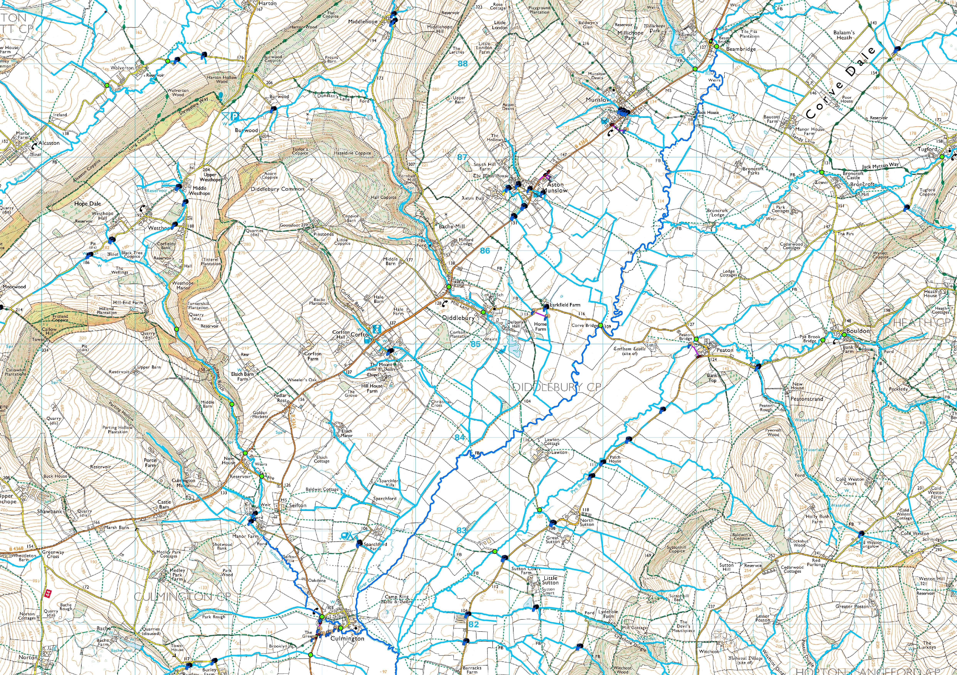

List of Properties at Flood Risk

Name | Contact | Address
Mr and Mrs Constable | 01584 841426 | Glebe Cottage, Diddlebury
Mr and Mrs Povall | 01584 841279 | Bouldon Farm, Bouldon
Mr and Mrs Robinson | 01584 841753 | Brook Cottage, Peaton
Mrs G Roose | 01584 841857 | Peaton Cottage, Peaton Strand
Karen and Ray Wilcox | 01584 861607 | Karray Cottage, Corfton
Mr Dave Wain | 01584 861817 | Warwick Cottage, Corfton
Mr and Mrs Fuller | 01584 841694 | Mill House, Bache Mill
Clive Martyn and Sharon Walters | 01584 841346 | Roseford, Bache Mill
Mr Chris Jones | 07891 781123 | Patch Cottage, Sutton
 |  | Lower Middlehope Barn, Middlehope

List of Vulnerable People at Flood Risk
Name | Contact | Address | Vulnerability | Assistance needed | Checked time

Guidance Notes

Be aware that at times of severe rainfall, mill lane, diddlebury can flood at the bottom corner by the bridge. Flood water can reach a depth of about half a metre making the road impassable to normal traffic, pedestrians and cyclists.
If you do have a vehicle which can drive through the flood water, please drive slowly as if you drive quickly, the waves you GENERATE will exacerbate flooding of nearby properties.
The flood waters generally recede after an hour or two so if your trip is not urgent, it is better to try again later. If you do have to get through, then the shortest alternative route is via beambridge and broncroft.
The ford on bache mill can also sometimes become impassable for an hour or two. There is no alternative route here.
In peaton strand and sutton, field run off can close roads temporarily.
The road in the lower part of corfton can occasionally become impassable temporarily.

