Open Invitation to visit Millichope Gardens & Walled Garden: July 13th – 17th, 9am-4pm
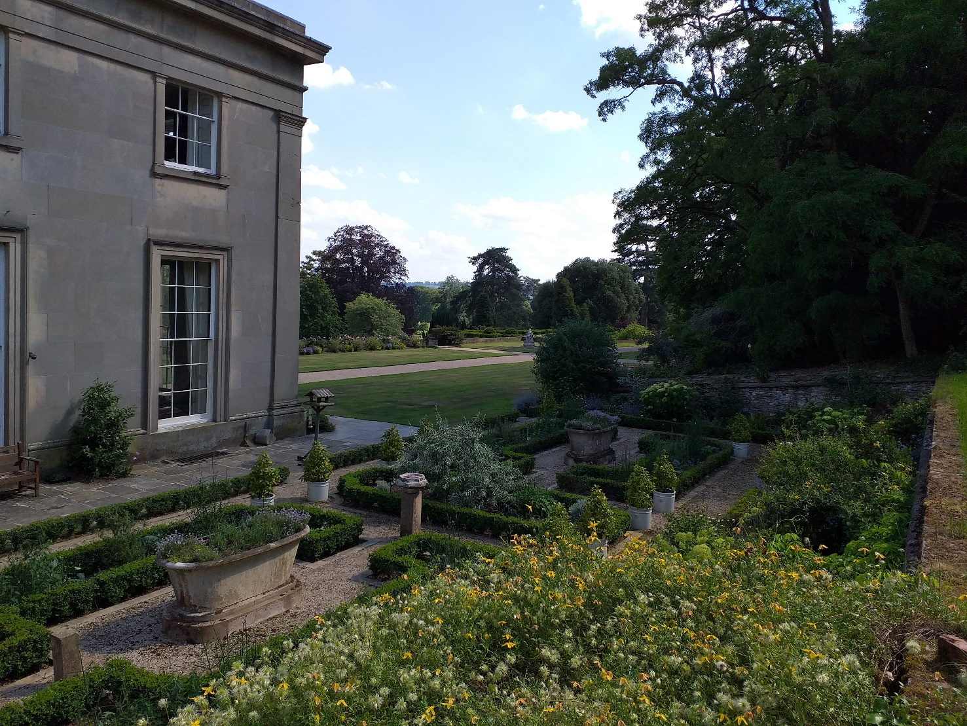
Following a successful opening in June we are re-opening the Millichope gardens from Monday 13th –Friday 17th July.
Also included will be The Walled Garden with teas, coffees and light snacks served outside, subject to spacing.
This is an open invitation, so there is no ticket charge.
Unfortunately, the NGS are not able to associate with the event but we will have an honesty box for donations to the same charities (details provided on the box). Dogs on leads are welcome. Picnicking is allowed (but kindly not in the walled garden). Due to the Covid-19 restrictions we can’t provide WC facilities.
Parking is via the Park by the cascades (NOT the front drive) & will be sign-posted from the road (B4368) with clear signs where to self-park as you enter the Parkland.
Should you wish to get in touch please contact the Estate Office: Tel 01584 84107 or email: estateoffice@millichope.co.uk
Please note a separate invitation to a ‘walk & talk’ around the veteran trees in the Millichope parkland on Wednesday 15th July (4pm – 6pm)

Temple Roses
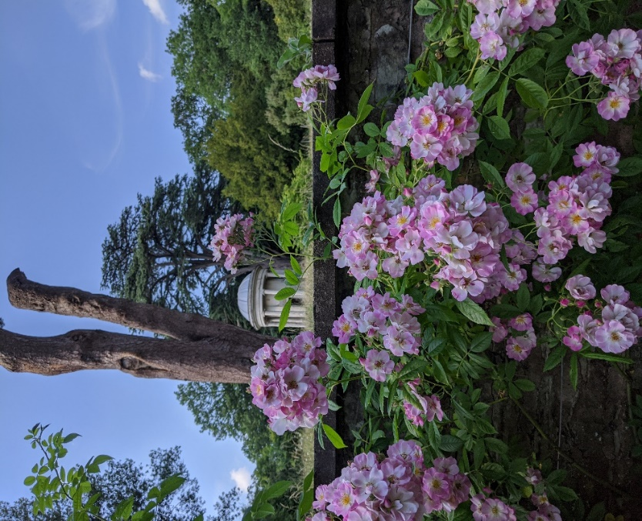

The Walled Garden
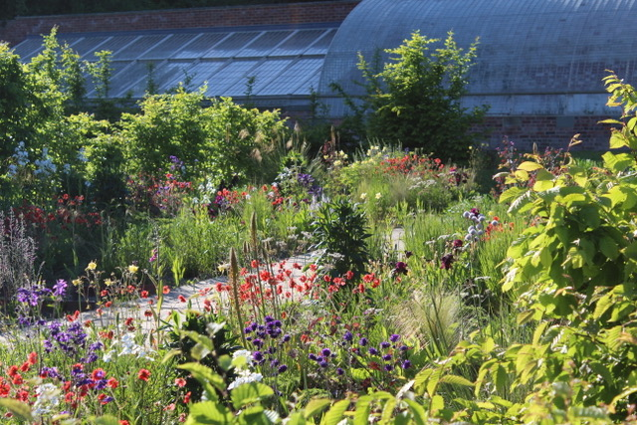

Water Garden
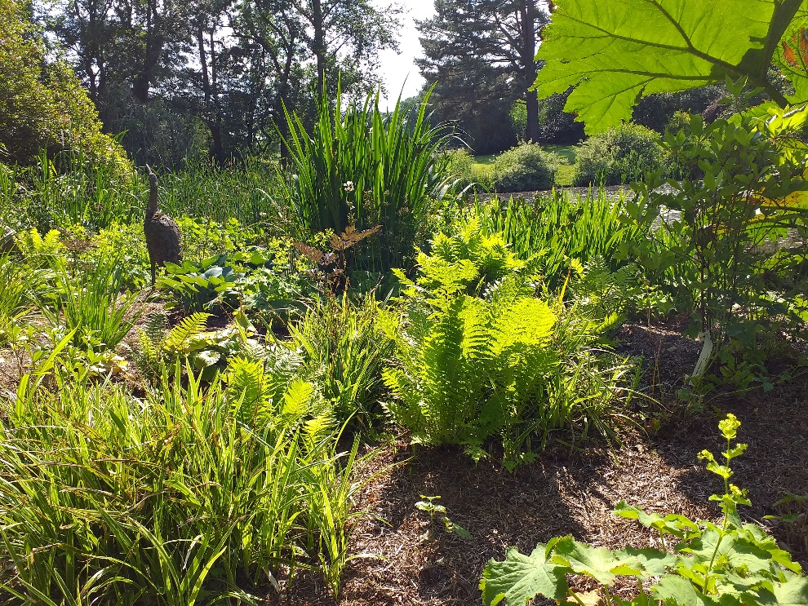
Wildflower meadow & Orchids
