Our Customer
Severn Trent Water
PO Box 407
Darlington
DL1 9WD

14 May 2020

: Please keep this letter handy until the work is complete:

Dear Customer

We’re improving your supply of wonderful water…
Every so often, we need to replace old water pipes. That’s because the risk of bursts increases as the years pass and we’re really keen to avoid this. Therefore, we’re going to replace some of the old pipes around the Corfton area with brand new ones.

Why we’re doing this work?
The water pipes in the area have served your community well for many years, but have recently been showing their age, resulting in a number of bursts. When this happens, we have to carry out emergency repairs (and we all know how inconvenient that can be) and your drinking water supplies may be affected. In order to ensure supplies are secure in the future we’re going to renew some of those pipes. This means there’ll be some short-term inconvenience – but the advantage of having this work take place will be worth it and secure the network for the future.

When and where is the work taking place?
The work will start on 1 June 2020 and will take approximately eight weeks to complete.
We will start at the top of Corfton Bache and work down across the junction of the B4368, then down towards Karray Cottage. Although it’s really important, we also know our work can be inconvenient. During the work we’ll need to close sections of the road to through traffic. We’re really sorry about this, but it will mean we keep everyone safe and get the work done as quickly as possible. A diversion will be in place and access to homes and businesses will be maintained at all times. A map of the work location is overleaf. Please be assured that we, and our contract partner Heartlands, will be doing everything we can to minimise the disruption and get the work finished as quickly as we can. Please note that the programme can change due to circumstances out of our control.
Will my water supply be affected?
If we plan to interrupt your water supply, we’ll notify you in advance with a card stating the date and the earliest start and latest end time of the interruption. It’s advisable to avoid using any appliances connected to the water supply during this period.

During or after the work, there’s a small chance your water may appear discoloured. This is nothing to worry about and will quickly go back to normal. We’ll be doing our best to make sure your water supply is unaffected for the duration of our work. To find out more about clearing discoloured tap water please visit our website www.stwater.co.uk/discolouration
Location of work Red line indicates work area
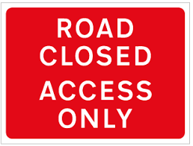
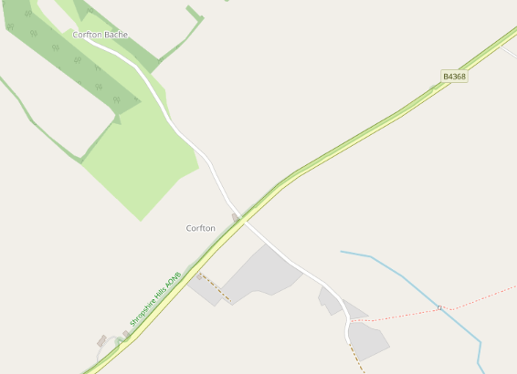
FINISH
24.07.20
START
01.06.20
Multi Way Traffic Lights 13.07.20 to 24.07.20

Retail Businesses
If you own or operate a business which receives visiting customers who purchase goods or services from you and our works are affecting your sales income then please contact our Business Loss Team - BusinessLoss@severntrent.co.uk for further advice.
Who can I contact about the work?
- Get in touch with Jim Clarke – Severn Trent Site Supervisor, on 07970 183696 between 08:00 – 17:00 Mon - Fri
- Get in touch with me Catherine Webb, on 07971 304604 between 08:00 – 17:00 Mon - Fri
- If you experience problems with your water or sewerage service while the work is being done, please call our 24-hour call centre on 0800 783 4444
- Please let us know how we are doing at: www.stwater.co.uk/howsourwork
Yours faithfully

Catherine Webb
Community Communications Officer – Severn Trent

