Invitation to a Walk & Talk around the veteran trees of Millichope park on Wednesday 15th July, 4pm-6pm
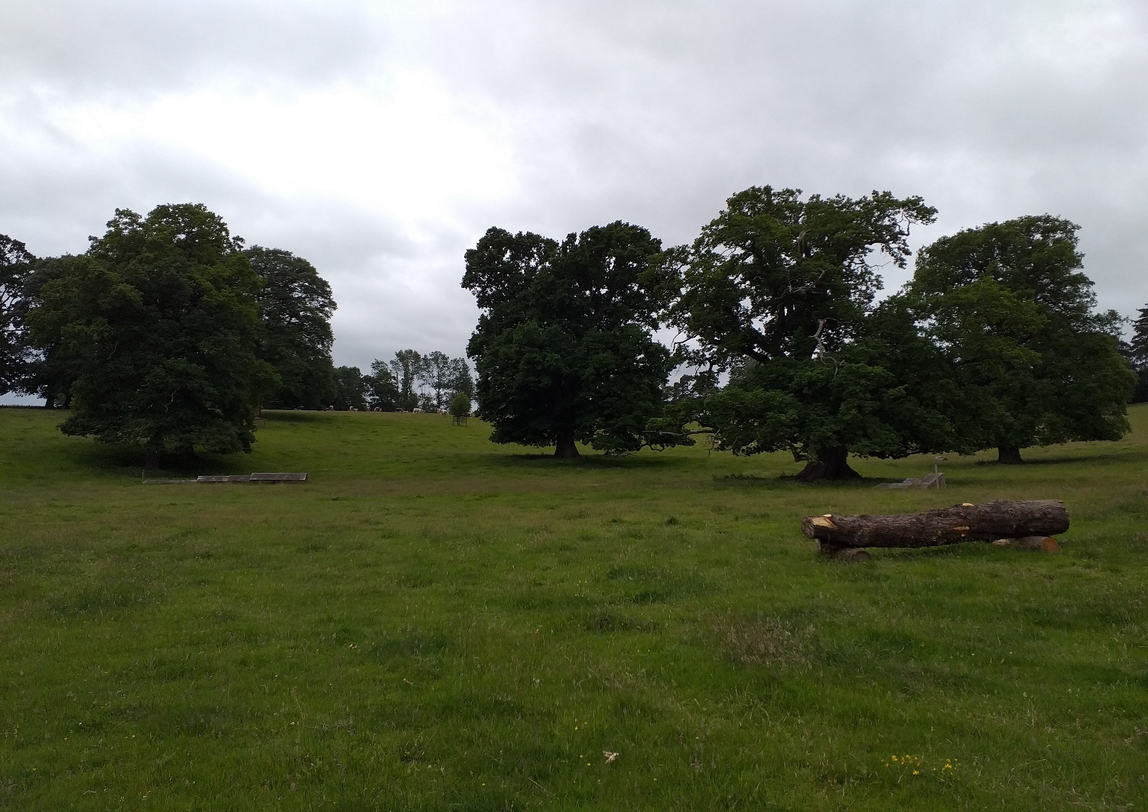

Millichope Parkland has some wonderful ancient trees (500 years old plus) that are sometimes overlooked on garden open days. This is an opportunity to join with Shropshire ecologists and tree experts who have kindly agreed to share some of their knowledge on a peripatetic homage to old giants.
This is an open invitation, so there is no ticket charge. There will be an honesty box for charitable donations (to the National Garden Scheme charities)
Parking is via the Park by the cascades (NOT the front drive) & will be sign-posted from the road (B4368) with clear signs where to self-park as you enter the Parkland.
Assembly will be in view of the Parking area at about 4.15pm – 4.30pm. Dogs on leads are welcome. Unfortunately, due to the Covid-19 restrictions we can’t provide WC facilities.
Should you wish to get in touch please contact the Estate Office: Tel 01584 841077

